FORENSIC REPORT MANAGEMENT SYSTEM

**MINI PROJECT REPORT**

***Submitted by***

**SHYAM SUNDAR K P [221501136]**

**SRI KEERTHANA R [221501142]**

**SUSHMITHA K S J [221501153]**

*In partial fulfillment for the award of the degree of*

**BACHELOR OF TECHNOLOGY**

**DEPARTMENT OF ARTIFICIAL INTELLIGENCE AND**

**MACHINE LEARNING**



**RAJALAKSHMI ENGINEERING COLLEGE (AUTONOMOUS) THANDALAM**

**CHENNAI-602105**

**BONAFIDE CERTIFICATE**

Certified that this project report “**FORENSIC REPORT MANAGEMENT SYSTEM**” is the bonafide work of **“SHYAM SUNDAR K P (221501136), SRI KEERTHANA R (221501142), SUSHMITHA K S J (221501153)”** who carried out the project work under my supervision.

**Submitted for the Practical Examination held on**

**SIGNATURE**

**Ms.M.Manju Assistant Professor,**

**Artificial Intelligence and MachineLearning Rajalakshmi Engineering College (Autonomous) Thandalam, Chennai - 602 105**

**INTERNAL EXAMINER EXTERNAl EXAMINER**

# ABSTRACT

The Forensic Report Management System is an advanced web-based application developed using PHP and MySQL, designed to streamline the process of reporting and managing forensic investigations. The primary goal of this system is to facilitate the efficient submission and tracking of forensic reports, ensuring that law enforcement agencies can respond promptly to criminal activities.

This system allows users to report crimes online by providing detailed descriptions and uploading relevant photos or videos of crime scenes. This feature enables immediate police action and aids in the swift resolution of criminal cases. Additionally, the system maintains a comprehensive database of lost and wanted criminals, making it easier for the authorities to disseminate information and for the public to stay informed.

The Forensic Report Management System also includes educational components, offering safety tips and guidelines to help users protect themselves and their communities. By integrating these functionalities, the system not only enhances the efficiency of forensic reporting but also fosters community engagement and awareness.

Our project provides a robust solution for modern forensic management needs, with the complete source code and executable files available for free download. This system represents a significant step forward in leveraging technology to improve public safety and streamline law enforcement processes.

# TABLE OF CONTENTS

1. **INTRODUCTION**
   1. INTRODUCTION
   2. OBJECTIVES
   3. MODULES

# SURVEY OF TECHNOLOGIES

* 1. SOFTWARE DESCRIPTION
  2. LANGUAGES
  3. .1PHP
     1. SQL
     2. HTML
     3. CSS
     4. JAVASCRIPT
     5. JQUERY
     6. BOOTSTRAP

# REQUIREMENT AND ANALYSIS

* 1. REQUIREMENT SPECIFICATION
  2. HARDWARE AND SOFTWARE SPECIFICATION
  3. ARCHITECTURE DIAGRAM
  4. ER DIAGRAM

# PROGRAM CODE

1. **RESULTS AND DICUSSION**
   1. UI AND FUNCTIONALITY OF THE PROJECT
   2. USER FEEDBACK
   3. CHALLENGES FACED DURING DEVELOPMENT
2. **CONCLUSION**
3. **REFERENCES**
4. **INTRODUCTION**

## INTRODUCTION

The forensic reporting system enables users to report crimes online by submitting descriptions and uploading photos or videos of crime scenes, allowing for immediate police action. This project aims to streamline crime reporting and enhance public safety through efficient and accessible technology.

## OBJECTIVES

* Enable users to report crimes online with detailed descriptions and multimedia evidence (photos/videos) for immediate police response.
* Provide up-to-date information on lost and wanted criminals to assist the public and law enforcement in crime prevention.
* Offer a comprehensive database of missing persons, allowing users to search for and report sightings within their district and city.
* Supply contact details and addresses of local police stations, ensuring easy access to law enforcement services.
* Disseminate recent developments and news related to crime, enhancing public awareness and safety.

## MODULES

### USER REGISTRATION AND LOGIN

This module allows new users to create accounts by providing their personal details and setting up a secure password. Existing users can log in using their credentials to access the platform's features.

### CRIME REPORTING

The Crime Reporting module enables users to file reports about criminal activities they have witnessed or experienced. Users can provide detailed descriptions, attach evidence, and submit their reports directly to the authorities. This module ensures that all submitted information is securely transmitted and stored for further investigation.

### MULTIMEDIA UPLOAD (PHOTOS/VIDEOS)

This module allows users to upload multimedia files such as photos and videos to support their crime reports. Users can attach evidence related to the reported crime, which can be critical for investigations. The system ensures that all multimedia uploads are securely stored and accessible only to authorized personnel.

### CRIMINAL DATABASE (LOST AND WANTED)

The Criminal Database module maintains records of lost individuals and wanted criminals. Users and law enforcement can search for information about suspects, missing persons, and fugitives. This centralized database aids in the swift dissemination of crucial information and assists in ongoing investigations.

### POLICE STATION DIRECTORY

The Police Station Directory provides users with contact information and addresses of all police stations within the jurisdiction. Users can quickly find and connect with their nearest police station for assistance. This module ensures that citizens have easy access to law enforcement agencies.

### CRIME NEWS AND UPDATES

This module delivers the latest news and updates related to criminal activities and law enforcement efforts. Users can stay informed about recent crimes, safety alerts, and ongoing investigations. The module serves as an information hub, keeping the community aware and vigilant.

### ADMIN DASHBOARD

The Admin Dashboard is a comprehensive control panel for system administrators. It provides tools for managing user accounts, overseeing crime reports, monitoring multimedia uploads, and updating the criminal database. The dashboard ensures that administrators can efficiently manage the system and respond to emerging issues swiftly.

## SOFTWARE DESCRIPTION

* The forensic Reporting System utilizes various software technologies to ensure a robust and scalable platform. The core technologies include PHP for server-side scripting and MySQL for database management. The front-end is developed using HTML, CSS, and JavaScript, with Bootstrap ensuring a responsive and user-friendly design. The system runs on servers like XAMPP which provide a stable environment for developing and deploying the application. Together, these technologies create a powerful, efficient, and user-centric web application for crime reporting and management

# 2. SURVEY OF TECHNOLOGIES

.

## LANGUAGES

The forensic Reporting project leveraged several programming languages and technologies to build the system. Each language was chosen for its specific strengths and contributions to different aspects of the project.

## PHP

PHP (Hypertext Preprocessor) is a widely-used open-source scripting language suited for web development. It was employedfor server-side scripting to handle data processing, database

interactions, and dynamic content generation. Key features of PHPutilized in this project include:

* + - * Server-side scripting
      * Form handling
      * Database connectivity using MySQL
      * Session management

## SQL

SQL (Structured Query Language) is used for managing and manipulating relational databases. The project used SQL to interact with the MySQL database for various CRUD (Create,Read, Update,Delete) operations. Key SQL functionalities include:

* Data definition and manipulation (DDL and DML)
* Querying the database
* Data normalization and integrity constraints

## HTML

HTML (HyperText Markup Language) is the standard language forcreating web pages. It was used to structure the content of the

Recipe Cookbook application. Key features of HTML utilized in thisproject include:

* + - * Page structuring with elements like headings, paragraphs,lists, and forms
      * Embedding images and media
      * Creating links and navigation

## JAVASCRIPT

JavaScript is a versatile programming language used for adding

interactivity to web pages. In this project, JavaScript was used forclient-side scripting to enhance user experience. Key JavaScript features utilized include:

* + - * DOM manipulation for dynamic content updates
      * Event handling (e.g., form validation, button clicks)
      * AJAX for asynchronous data loading

## JQUERY

j Query is a fast, small, and feature-rich JavaScript library. It simplifies tasks like HTML document traversal and manipulation,

event handling, and AJAX interactions. Key jQuery functionalitiesused in this project include:

* + - * Simplified AJAX requests
      * DOM manipulation and traversal
      * Enhancing user interface elements (e.g., animations, effects)

## BOOTSTRAP

Bootstrap is a popular front-end framework for developing responsive and mobile-first web projects. It was used to designand develop a responsive layout for the Recipe Cookbook. KeyBootstrap features utilized in this project include:

* + - * Grid system for responsive design
      * Pre-designed components like navbars, buttons, and forms.

# 3. REQUIREMENTS AND ANALYSIS

## REQUIREMENT SPECIFICATION

### User Requirements:

* 1. Users should be able to report crimes online by providing detailed descriptions and uploading photos or videos of crime scenes.
  2. Users should have access to a database of lost and wanted criminals, along with information on missing persons in their district and city.
  3. Users should receive updates on recent crime developments and safety tips to stay informed and enhance their safety awareness.

### System Requirements:

The system should ensure data integrity and provide a secure environment for user information.

## HARDWARE AND SOFTWARE REQUIREMENTS

* **Hardware:**

1. Server with minimum 4GB RAM and 100GB storage.
2. Client devices with internet access.

* **Software:**

1. Operating System: Linux/Windows
2. Web Server: Apache
3. Database: MySQL
4. Languages: PHP, SQL, HTML, CSS, JavaScript
5. Frameworks: Bootstrap

## ARCHITECTURE DIAGRAM:

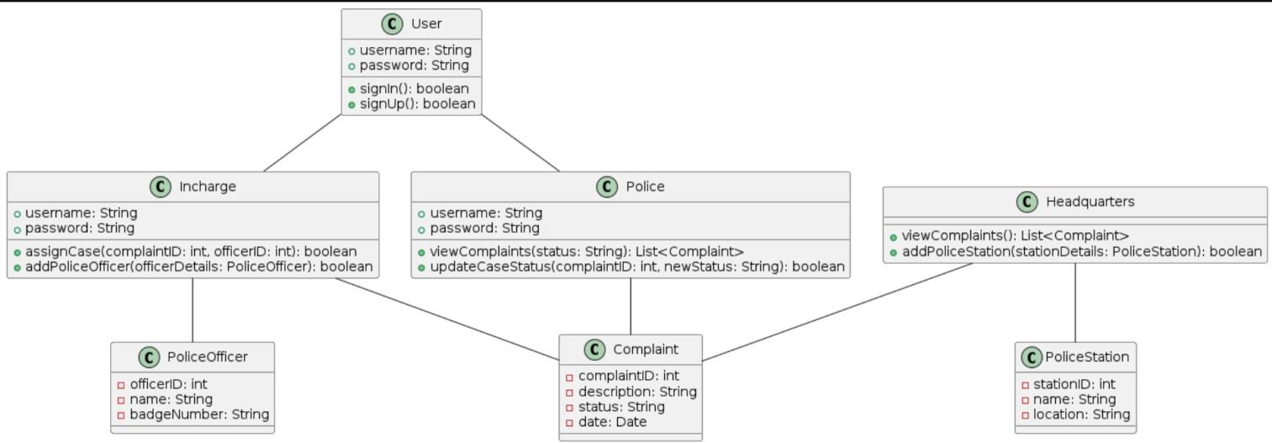

**FORENSIC REPORTING SYSTEM ARCHITECTURE:**

### CLIENT-SIDE INTERACTION:

**Client (Web Browser/Mobile):**

* Users interact with the system through a web browser or mobile device.
* The front-end is built using HTML, CSS, JavaScript, and Bootstrap for responsive design.

### SERVER-SIDE HANDLING:

**Web Server (Apache/Nginx):**

* The web server handles incoming HTTP requests from the client.
* It processes these requests and interacts with the application logic.

### APPLICATION LOGIC (PHP):

* PHP scripts process the client requests, perform necessary operations, and generate dynamic content.
* Handles user authentication, complaint submission, police login, case status updates, assignment of cases, addition of police officers, and interaction with the database.

### DATA MANAGEMENT

Database Server (MySQL):

* Stores all complaint data, user information, police officer details, police station information, and other relevant data.
* The PHP application communicates with the MySQL database to store, retrieve, update, and delete data as required.

.

## ER DIAGRAM:

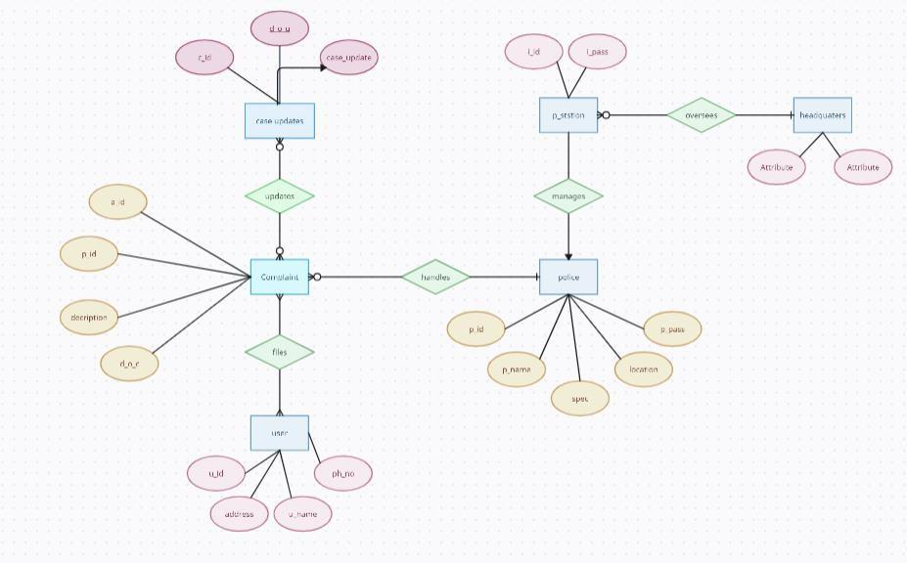

This Entity-Relationship diagram provides a comprehensive overview of how entities interact within the forensic reporting system, facilitating the management and resolution of complaints effectively.

In the forensic reporting system, various entities interact with each other to manage complaints, assign cases, and oversee operations. Here's an explanation of the entities and their relationships:

## ENTITIES:

### USER:

Represents users interacting with the system. Users have unique identifiers (userID), usernames, and passwords for authentication.

### POLICE OFFICER:

Represents police officers responsible for handling complaints. Each police officer has a unique identifier (officerID) and a name. Additionally, police officers can update the status of cases, indicating progress or resolution.

### COMPLAINT:

Represents complaints lodged within the system. Each complaint has a unique identifier (complaintID) and a type (complaint Type) indicating the nature of the complaint.

### INCHARGE:

Represents individuals in charge of managing cases and police officers. Incharges have functionalities to assign cases to police officers, add new police officers to the system, and view complaints based on location.

### HEADQUARTERS:

Represents the central management entity overseeing the entire system. Headquarters have functionalities to view all complaints registered in the system and to add new police station.

## RELATIONSHIPS:

### USER -- COMPLAINT:

Users can submit complaints, establishing a one-to-many relationship where one user can lodge multiple complaints.

### POLICE OFFICER -- COMPLAINT:

Police officers are assigned to handle complaints, indicating a one-to-many relationship where one police officer can handle multiple complaints.

### INCHARGE -- POLICE OFFICER:

In-charges manage and oversee police officers, establishing a one-to-many relationship where one incharge can manage multiple police officers.

### HEADQUARTERS -- COMPLAINT:

The headquarters oversee all complaints registered in the system, establishing a one-to-many relationship where one headquarters can manage multiple complaints.

### INCHARGE -- POLICE OFFICER:

In charges assign cases to police officers, indicating a one-to-many relationship where one incharge can assign cases to multiple police officers.

# PROGRAM CODE

## USER LOGIN:

<!DOCTYPE html>

<html>

<head>

<?php

if(isset($_POST['s']))

{

session_start();

$_SESSION['x']=1;

$conn=mysqli_connect("localhost","root",""); if(!$conn)

{

die("could not connect".mysqli_error());

}

mysqli_select_db($conn,"crime_portal");

if($_SERVER["REQUEST_METHOD"]=="POST")

{

$u_id=$_POST['email'];

$_SESSION['u_id']=$u_id;

if(mysqli_num_rows($result)==0)

{

$message = "Id or Password not Matched.";

echo "<script type='text/javascript'>alert('$message');</script>";

}

else

{

header("location:complainer_page.php");

}

}

}

?>

<link rel="stylesheet" type="text/css" href="https://maxcdn.bootstrapcdn.com/bootstrap/3.3.5/css/bootstrap.min.css">

<link rel="stylesheet" type="text/css" href="https://maxcdn.bootstrapcdn.com/font-awesome/4.4.0/css/font- awesome.min.css">

<link href="[http://fonts.googleapis.com/css?family=Lato:300,400,700,300italic,400italic,700italic](http://fonts.googleapis.com/css?family=Lato%3A300%2C400%2C700%2C300italic%2C400italic%2C700italic)" rel="stylesheet" type="text/css">

<script>

function f1()

{

var sta2=document.getElementById("exampleInputEmail1").value;

var x3=sta3.indexOf(' '); if(sta2!="" && x2>=0){

document.getElementById("exampleInputEmail1").value=""; document.getElementById("exampleInputEmail1").focus(); alert("Space Not Allowed");

}

else if(sta3!="" && x3>=0){ document.getElementById("exampleInputPassword1").value=""; document.getElementById("exampleInputPassword1").focus(); alert("Space Not Allowed");

}

}

</script>

<title>Complainant Login</title>

</head>

<body style="background-size: cover; background-image: url(regi_bg.jpeg); background-position: center;">

<nav class="navbar navbar-default navbar-fixed-top" style="height: 60px;">

<div class="container">

<div class="navbar-header">

<a class="navbar-brand" href="home.php" style="margin-top: 5%;"><b>Crime Portal</b></a>

</div>

<div id="navbar" class="collapse navbar-collapse">

<ul class="nav navbar-nav">

<li class="active" style="margin-top: 5%;"><a href="userlogin.php">Complainer Login</a></li>

</ul>

</div>

</div>

</nav>

<div align="center" >

<div class="form" style="margin-top: 15%">

<form method="post">

<div class="form-group" style="width: 30%">

<label for="exampleInputEmail1"><h1 style="color: #fff;">User Id</h1></label>

<input type="email" class="form-control" id="exampleInputEmail1" aria-describedby="emailHelp" size="5" placeholder="Enter Email id" required name="email" onfocusout="f1()">

</div>

<div class="form-group" style="width:30%">

<label for="exampleInputPassword1"><h1 style="color: #fff;">Password</h1></label>

<input type="password" class="form-control" id="exampleInputPassword1" placeholder="Password" required name="password" onfocusout="f1()">

</div>

<button type="submit" class="btn btn-primary" name="s" onclick="f1()">Submit</button>

</form>

</div>

</div>

<div style="position: fixed;

</body>

</html>

## HOME PAGE:

<!DOCTYPE html>

<html>

<head>

<title>Crime Portal</title>

<link rel="stylesheet" type="text/css" href="https://maxcdn.bootstrapcdn.com/bootstrap/3.3.5/css/bootstrap.min.css">

<link rel="stylesheet" type="text/css" href="https://maxcdn.bootstrapcdn.com/font-awesome/4.4.0/css/font- awesome.min.css">

<link href="[http://fonts.googleapis.com/css?family=Lato:300,400,700,300italic,400italic,700italic](http://fonts.googleapis.com/css?family=Lato%3A300%2C400%2C700%2C300italic%2C400italic%2C700italic)" rel="stylesheet" type="text/css">

<link rel="stylesheet" type="text/css" href="home.css">

</head>

<body>

<nav class="navbar navbar-default navbar-fixed-top">

<div class="container">

<div class="navbar-header">

<button type="button" class="navbar-toggle collapsed" data-toggle="collapse" data-target="#navbar" aria- expanded="false" aria-controls="navbar">

<span class="sr-only">Toggle navigation</span>

<span class="icon-bar"></span>

<span class="icon-bar"></span>

<span class="icon-bar"></span>

</button>

<a class="navbar-brand" href="home.php"><b>Crime Portal</b></a>

</div>

<div id="navbar" class="collapse navbar-collapse">

<ul class="nav navbar-nav">

<li class="active"><a href="home.php">Home</a></li>

</ul>

<ul class="nav navbar-nav navbar-right">

<li><a href="userlogin.php">User Login <i class="fa fa-user"></i></a></li>

<li><a href="official_login.php">Official Login <i class="fa fa-user"></i></a></li>

</ul>

</div>

</div>

</nav>

<div class="container">

<div class="row">

<div class="col-lg-12">

<div class="content">

<h1>Have a Complaint?</h1>

<h3>Register Below &nbsp &nbsp<i class="fa fa-hand-o-down" aria-hidden="true"></i></h3>

<hr>

<a href="registration.php" class="btn btn-default btn-lg" role="button" aria-pressed="true">Sign Up!</a>

</div>

</div>

</div>

</div>

<script type="text/javascript" src="https://code.jquery.com/jquery-2.1.4.js"></script>

<script type="text/javascript" src="https://maxcdn.bootstrapcdn.com/bootstrap/3.3.5/js/bootstrap.min.js"></script>

</body>

</html>

## POLICE LOGIN:

<!DOCTYPE html>

<html>

<head>

<link rel="stylesheet" type="text/css" href="bootstrap.css">

<link rel="stylesheet" type="text/css" href="https://maxcdn.bootstrapcdn.com/bootstrap/3.3.5/css/bootstrap.min.css">

<link rel="stylesheet" type="text/css" href="https://maxcdn.bootstrapcdn.com/font-awesome/4.4.0/css/font- awesome.min.css">

<link href="[http://fonts.googleapis.com/css?family=Lato:300,400,700,300italic,400italic,700italic](http://fonts.googleapis.com/css?family=Lato%3A300%2C400%2C700%2C300italic%2C400italic%2C700italic)" rel="stylesheet" type="text/css">

<title>Police Login</title>

<?php

if(isset($_POST['s']))

{

session_start();

$_SESSION['x']=1;

$conn=mysqli_connect("localhost","root",""); if(!$conn)

{

die("could not connect".mysqli_error());

}

mysqli_select_db($conn,"crime_portal");

$message = "Id or Password not Matched.";

echo "<script type='text/javascript'>alert('$message');</script>";

}

else

{

header("location:police_pending_complain.php");

}

}

}

?>

<script> function f1()

{

var sta2=document.getElementById("exampleInputEmail1").value; var sta3=document.getElementById("exampleInputPassword1").value; var x2=sta2.indexOf(' ');

var x3=sta3.indexOf(' '); if(sta2!="" && x2>=0){

document.getElementById("exampleInputEmail1").value="";

document.getElementById("exampleInputEmail1").focus(); alert("Space Not Allowed");

}

else if(sta3!="" && x3>=0){ document.getElementById("exampleInputPassword1").value=""; document.getElementById("exampleInputPassword1").focus(); alert("Space Not Allowed");

}

}

</script>

</head>

<body style="color: black;background-image: url(locker.jpeg);background-size: 100%;background-repeat: no- repeat;">

<nav class="navbar navbar-default navbar-fixed-top">

<div class="container">

<div class="navbar-header">

<a class="navbar-brand" href="home.php"><b>Crime Portal</b></a>

</div>

<div id="navbar" class="collapse navbar-collapse">

<ul class="nav navbar-nav">

<li><a href="official_login.php">Official Login</a></li>

<li class="active"><a href="policelogin.php">Police Login</a></li>

</ul>

</div>

</div>

</nav>

<div align="center" >

<div class="form" style="margin-top: 15%">

<form method="post">

<div class="form-group" style="width: 30%">

<label for="exampleInputEmail1" ><h1 style="color:white">Police Id</h1></label>

<input type="text" name="email" class="form-control" id="exampleInputEmail1" aria- describedby="emailHelp" size="5" placeholder="Enter user id" required onfocusout="f1()">

</div>

<div class="form-group" style="width:30%">

<label for="exampleInputPassword1"><h1 style="color:white">Password</h1></label>

<input type="password" name="password" class="form-control" id="exampleInputPassword1" placeholder="Password" required onfocusout="f1()">

</div>

<button type="submit" class="btn btn-primary" name="s">Submit</button>

</form>

</div>

</div>

<

</body>

</html>

## INCHARGE COMPLAINER DETAILS:

<!DOCTYPE html>

<html>

<head>

<?php session_start();

if(!isset($_SESSION['x'])) header("location:inchargelogin.php");

$conn=mysqli_connect("localhost","root",""); if(!$conn)

{

die("could not connect".mysqli_error());

}

mysqli_select_db($conn,"crime_portal");

$cid=$_SESSION['cid'];

$i_id=$_SESSION['email'];

$result1=mysqli_query($conn,"SELECT location FROM police_station where i_id='$i_id'");

$q2=mysqli_fetch_assoc($result1);

$location=$q2['location'];

$query="select c_id,type_crime,d_o_c,description from complaint where c_id='$cid' and location='$location'";

$result=mysqli_query($conn,$query); if(isset($_POST['assign']))

{

if($_SERVER["REQUEST_METHOD"]=="POST")

{

$pname=$_POST['police_name'];

$res1=mysqli_query($conn,"SELECT p_id FROM police where p_name='$pname'");

$q3=mysqli_fetch_assoc($res1);

$pid=$q3['p_id'];

$res=mysqli_query($conn,"update complaint set inc_status='Assigned',pol_status='In Process',p_id='$pid' where c_id='$cid'");

$message = "Case Assigned Successfully";

echo "<script type='text/javascript'>alert('$message');</script>";

}

}

?>

<title>Assign Police</title>

<link rel="stylesheet" type="text/css" href="https://maxcdn.bootstrapcdn.com/bootstrap/3.3.5/css/bootstrap.min.css">

<link rel="stylesheet" type="text/css" href="https://maxcdn.bootstrapcdn.com/font-awesome/4.4.0/css/font- awesome.min.css">

<link href="[http://fonts.googleapis.com/css?family=Lato:300,400,700,300italic,400italic,700italic](http://fonts.googleapis.com/css?family=Lato%3A300%2C400%2C700%2C300italic%2C400italic%2C700italic)" rel="stylesheet" type="text/css">

</head>

<body>

<nav class="navbar navbar-default navbar-fixed-top">

<div class="container">

<div class="navbar-header">

<button type="button" class="navbar-toggle collapsed" data-toggle="collapse" data-target="#navbar" aria- expanded="false" aria-controls="navbar">

<span class="sr-only">Toggle navigation</span>

<span class="icon-bar"></span>

<span class="icon-bar"></span>

<span class="icon-bar"></span>

</button>

<a class="navbar-brand" href="home.php"><b>Crime Portal</b></a>

</div>

<div id="navbar" class="collapse navbar-collapse">

<ul class="nav navbar-nav navbar-right">

<li ><a href="Incharge_complain_page.php">View Complaints</a></li>

<li class="active" ><a href="incharge_complain_details.php">Complaints Details</a></li>

<li><a href="inc_logout.php">Logout &nbsp <i class="fa fa-sign-out" aria-hidden="true"></i></a></li>

</ul>

</div>

</div>

</nav>

<div style="padding:50px; margin-top:10px;">

<table class="table table-bordered">

<thead class="thead-dark" style="background-color: black; color: white;">

<tr>

<th scope="col">Complaint Id</th>

<th scope="col">Type of Crime</th>

<th scope="col">Date of Crime</th>

<th scope="col">Description</th>

</tr>

</thead>

<?php

while($rows=mysqli_fetch_assoc($result)){

?>

<tbody style="background-color: white; color: black;">

<tr>

<td><?php echo $rows['c_id']; ?></td>

<td><?php echo $rows['type_crime']; ?></td>

<td><?php echo $rows['d_o_c']; ?></td>

<td><?php echo $rows['description']; ?></td>

</tr>

</tbody>

<?php

}

?>

</table>

</div>

<div>

<form method="post">

<select class="form-control" name="police_name" style="margin-left:40%; width:250px;">

<?php

$p_name=mysqli_query($conn,"select p_name from police where location='$location'"); while($row=mysqli_fetch_array($p_name))

{

?>

<option> <?php echo $row[0]; ?> </option>

<?php

}

?>

</select>

<input type="submit" name="assign" value="Assign Case" class="btn btn-primary" style="margin- top:10px; margin-left:45%;">

</form>

</div>

<script type="text/javascript" src="https://code.jquery.com/jquery-2.1.4.js"></script>

<script type="text/javascript" src="https://maxcdn.bootstrapcdn.com/bootstrap/3.3.5/js/bootstrap.min.js"></script>

</body>

</html>

# RESULTS AND DISCUSSION

## USER INTERFACE:

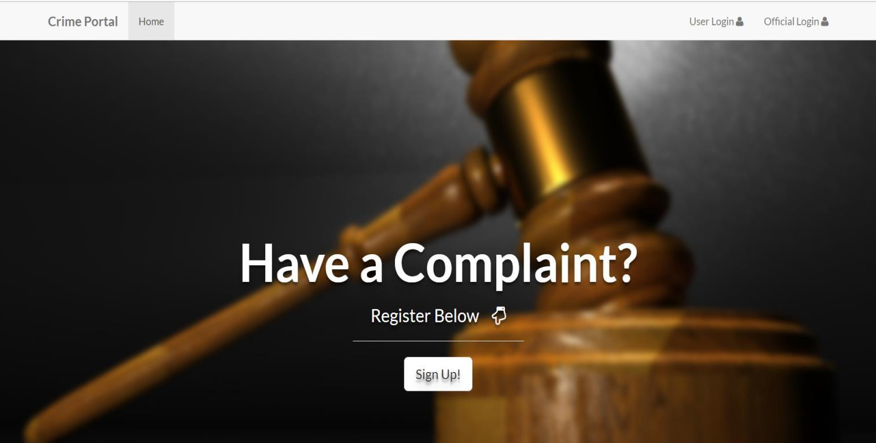

**Fig 5.1 Login page**

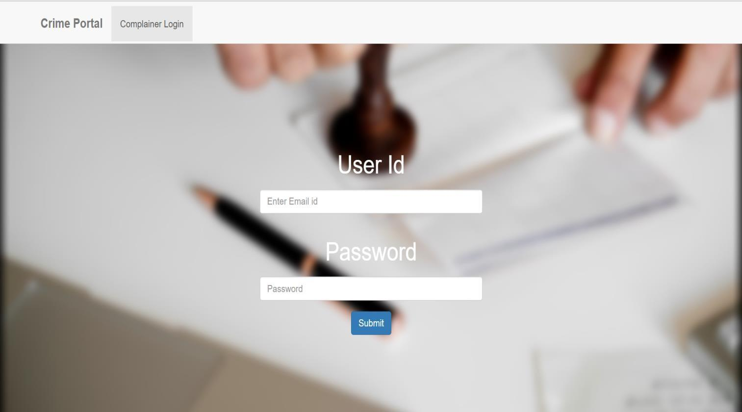

**Fig 5.2 Complainer login page**

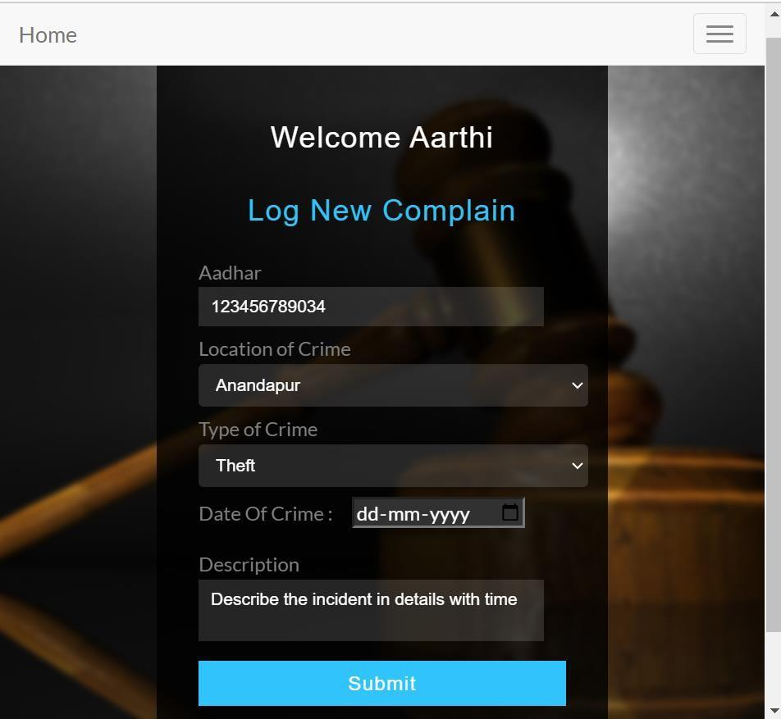

**Fig 5.3 Complaint page**

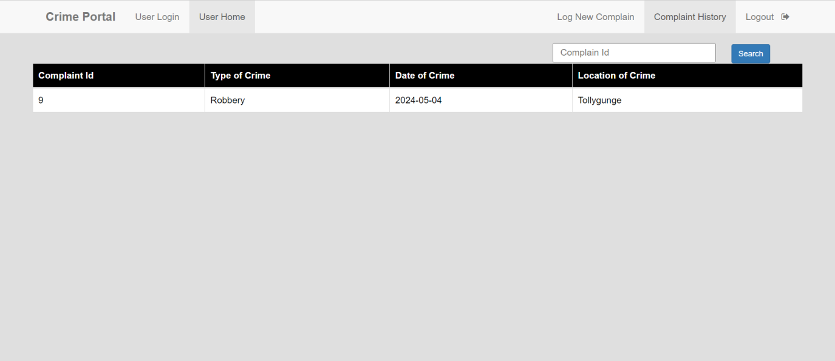

**Fig 5.4 Complaint History**

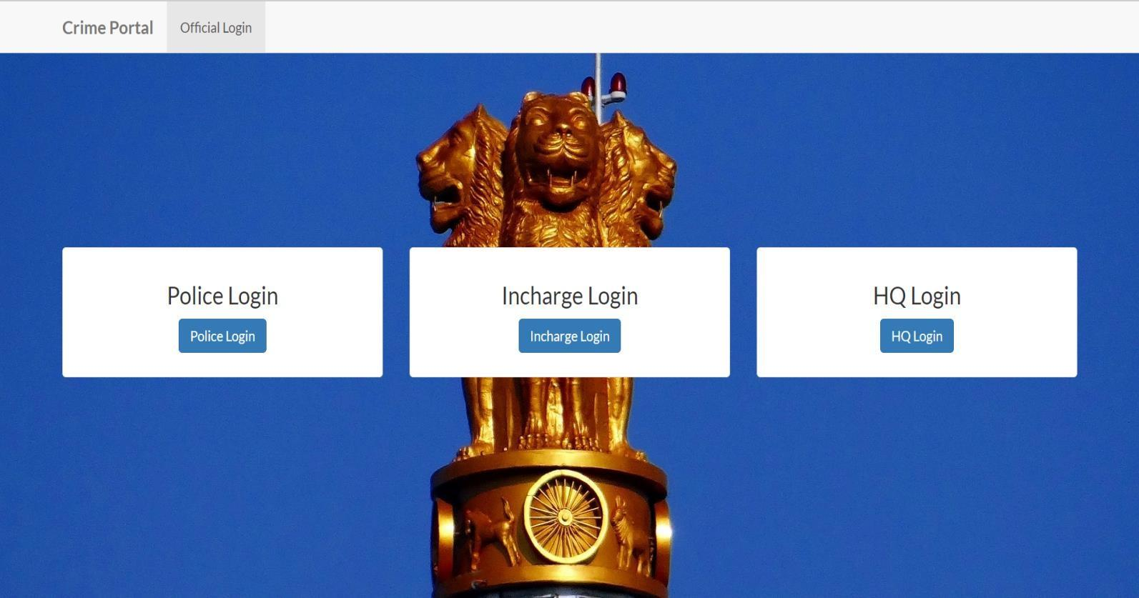

**Fig 5.5 Official Login**

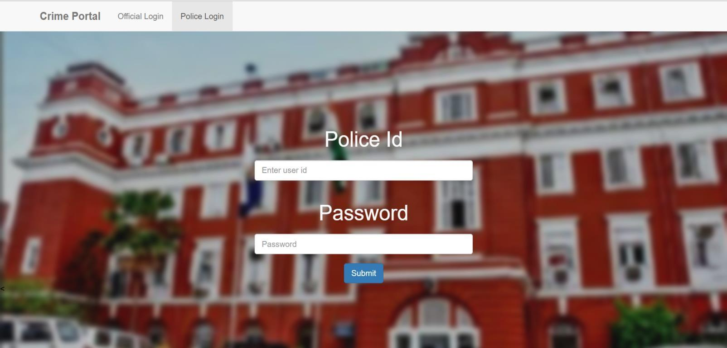

**Fig 5.6 Police login**

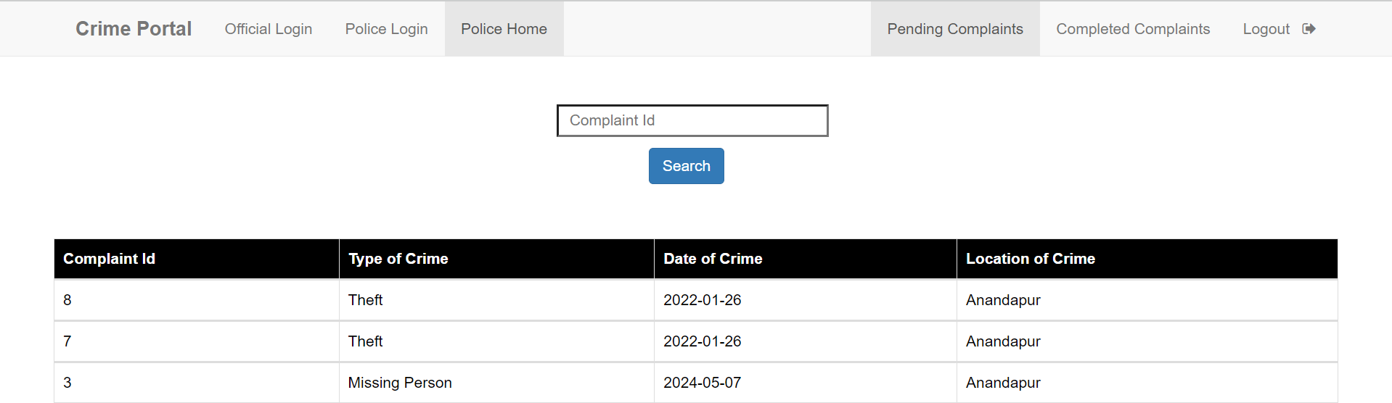

**Fig 5.7 Pending Complaints**

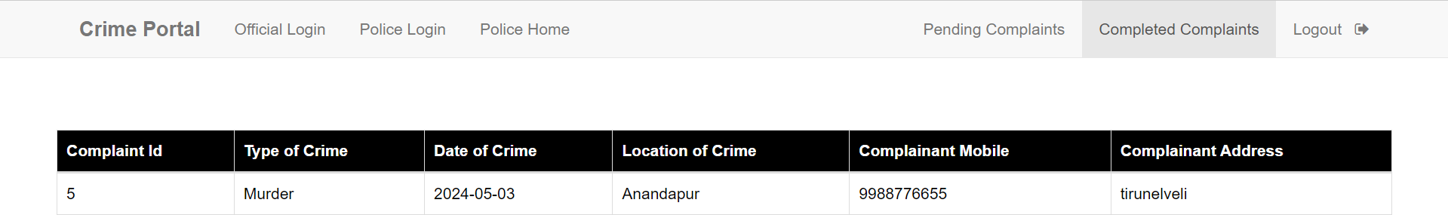

**Fig 5.8 Completed Complaints**

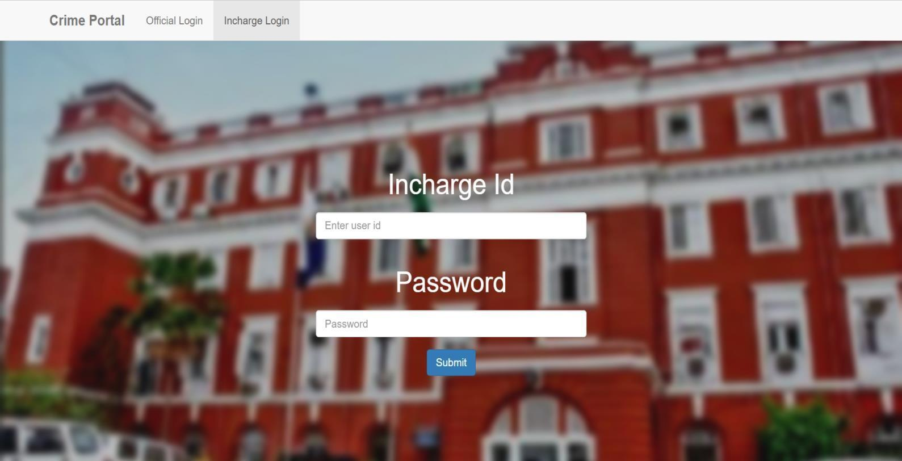

**Fig 5.9 Incharge Login**

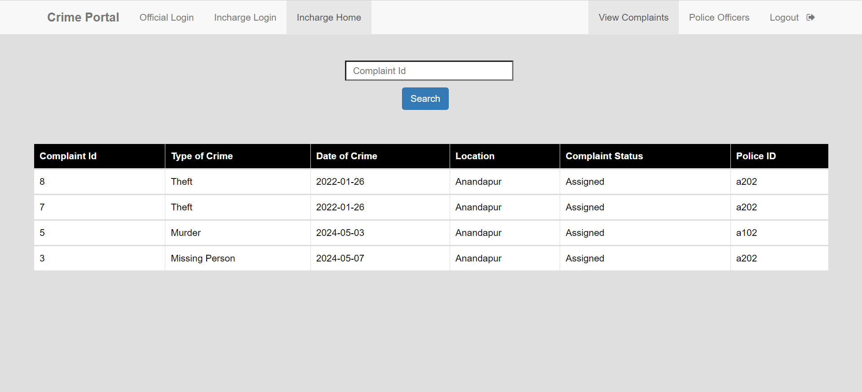

**Fig 5.10 Incharge Home**

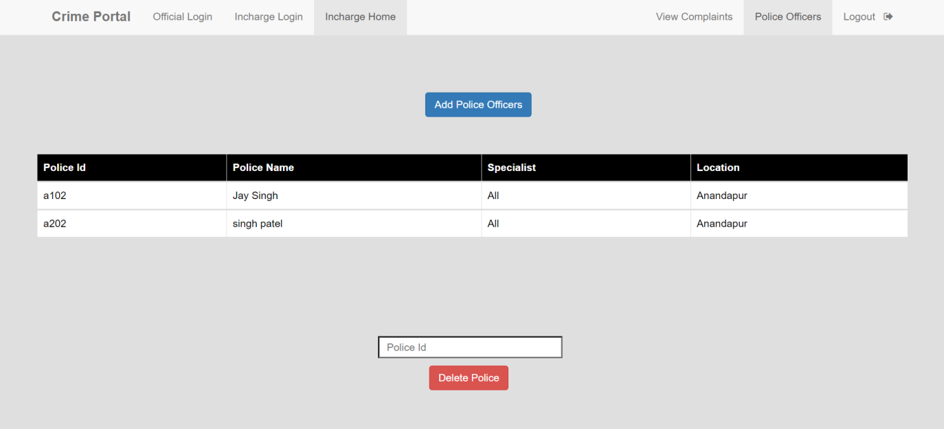

**Fig 5.11 Add Police Officers**

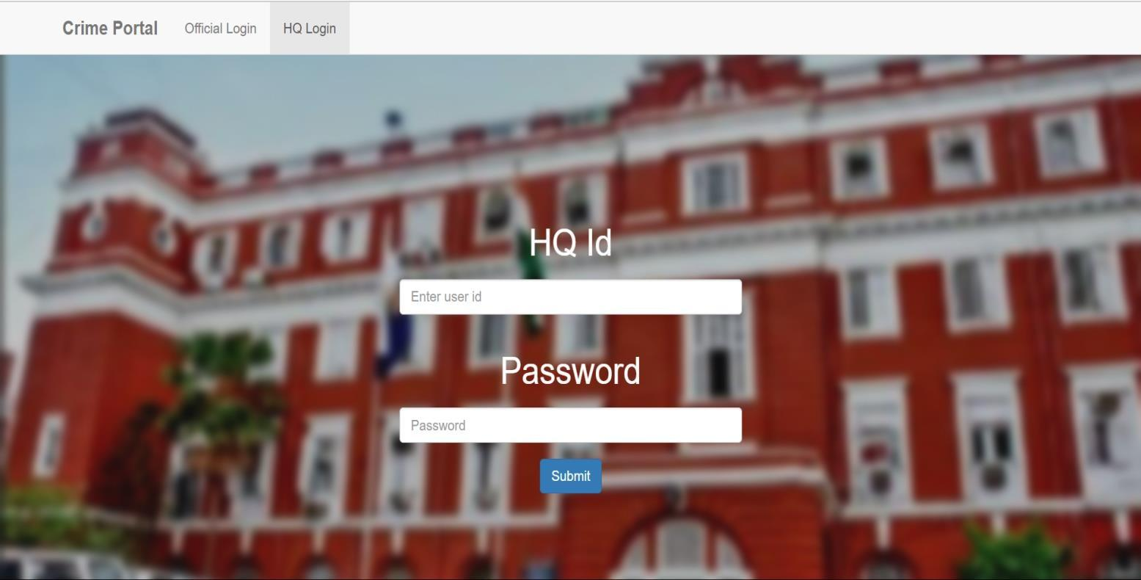

**Fig 5.12 Headquaters login**

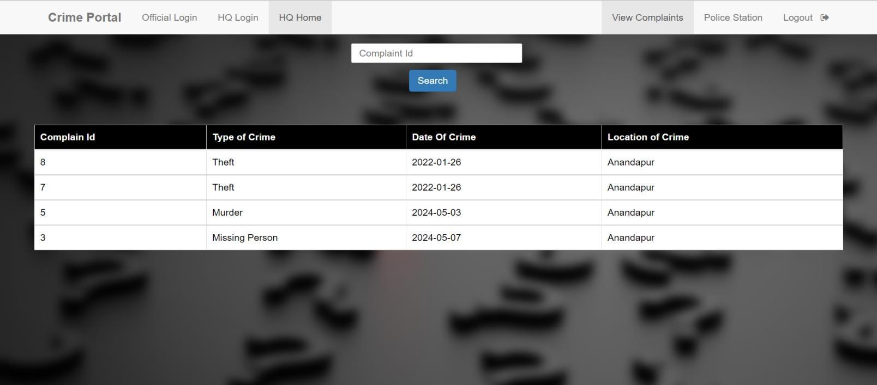

**Fig 5.13 View Complaints**

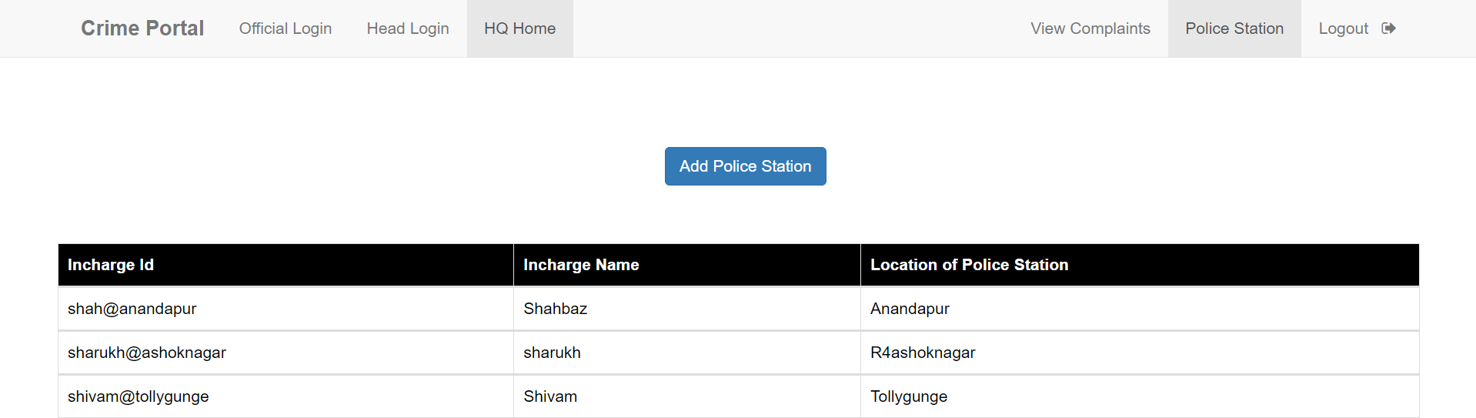

**Fig 5.14 Add Police Station**

## FUNCTIONALITY OF THE PROJECT

The Forensic Reporting System project was developed with the goal of providing a robust platform for managing and reporting forensic complaints efficiently. The system encompasses various functionalities tailored to meet the specific needs of users involved in the forensic reporting process. The key functionalities of the system are outlined below:

### USER REGISTRATION AND AUTHENTICATION:

1.Users can register for an account by providing necessary details such as username, password, and other relevant information.

2.Secure authentication mechanisms ensure that users can securely log in and log out of the system using their credentials, safeguarding sensitive information.

### COMPLAINT MANAGEMENT:

1.Users can submit complaints through the system, providing detailed information regarding the nature of the complaint, date, and other pertinent details.

2.The system allows users to view, update, and delete their complaints as needed, providing flexibility and control over the complaint management process.

### CASE STATUS UPDATE:

1.Police officers have the capability to update the status of cases assigned to them, indicating progress or resolution of the reported complaint

### ASSIGNMENT OF CASES:

1.In charges can assign cases to specific police officers, ensuring efficient distribution of workload and timely resolution of complaints

### POLICE OFFICER AND POLICE STATION MANAGEMENT:

1.In charges have the authority to add new police officers to the system, facilitating the expansion of the workforce as needed.

2.Headquarters can add new police stations to the system, ensuring that the coverage area for forensic reporting is comprehensive and efficient.

### VIEWING AND FILTERING COMPLAINTS:

1.In charges can view complaints based on location, allowing for targeted management and allocation of resources.

## 3.2 USER FEEDBACK

User feedback was collected during the testing phase of the project. Here aresome highlights:

### 3.2.1 POSITIVE FEEDBACK:

* + - 1. Ease of Use: Users appreciated the intuitive interface and found iteasy to navigate through the various features.
      2. Functionality: The ability to submit complaints, manage case statuses, and view location-based complaints was highly valued.
      3. Visual Appeal: Users liked the clean and visually appealing design of the system, which enhanced their overall experience.

### 3.2.2 AREAS FOR IMPROVEMENT:

* Search Functionality: Some users suggested enhancing the searchfunctionality to include more filters.
* Integration with Social Media: Users expressed interest in features that would allow them to share complaints or updates on social media platforms for broader awareness and engagement.

## 3.3 CHALLENGES FACED DURING DEVELOPMENT

Developing the Forensic Management System posed several challenges, which were addressed through careful planning and strategic solutions:

### INTEGRATION OF COMPONENTS:

1. Integrating different components such as user authentication, complaint management, and case status updates presented challenges in ensuring seamless communication between modules.
2. Solution: Careful planning and adherence to consistent coding standards helped mitigate integration issues, ensuring smooth functionality across the system.

### DATABASE DESIGN:

1.Designing a normalized database to handle complex relationships between users, complaints, police officers, and police stations was challenging.

2.Solution: Iterative testing and refinement of the database schema ensured a robust and efficient database design, accommodating the intricacies of the system's data structure.

### RESPONSIVE DESIGN:

1.Ensuring that the web application was fully responsive across various devices required extensive testing and adjustments to CSS and layout.

2.Solution: Utilizing Bootstrap framework and conducting thorough testing on different devices helped achieve a responsive design, enhancing user experience across platforms.

### SECURITY CONCERNS:

1.Implementing secure user authentication and data protection measures was crucial to safeguard user information and maintain system integrity.

2.Solution: Measures such as using prepared statements to prevent SQL injection, implementing HTTPS for secure data transmission, and thorough validation of user inputs were implemented to enhance security and protect sensitive data.

### USER EXPERIENCE (UX) DESIGN:

1.Designing an intuitive and user-friendly interface that caters to all user needs posed a continuous challenge.

2.Solution: Regular feedback from test users and iterative design adjustments were instrumental in improving the overall UX, ensuring that the system meets user expectations and facilitates efficient operation.

# 4.CONCLUSION

The Forensic Reporting System project effectively achieves its objectives by delivering a comprehensive and efficient platform for managing forensic complaints. Through the integration of essential functionalities such as user authentication, complaint management, case status updates, and assignment of cases, the system streamlines the forensic reporting process and enhances operational efficiency for law enforcement agencies and investigative authorities.

Utilizing modern web technologies and adhering to best practices in software development, the Forensic Reporting System ensures a robust and scalable solution capable of handling the complexities of forensic investigations. The system's intuitive interface and user-friendly design contribute to an enhanced user experience, facilitating seamless navigation and interaction with the platform.

By addressing key challenges in the forensic reporting domain and implementing strategic solutions, the Forensic Reporting System stands as a valuable tool for enhancing forensic investigation processes and improving public safety. Overall, the project's successful development and deployment mark a significant milestone in advancing forensic reporting capabilities and fostering greater collaboration among law enforcement agencies, investigative authorities, and the community.

# 5. REFERENCES

PHP DOCUMENTATION:

1.Documentation:https://[www.php.net/docs.php](http://www.php.net/docs.php)

2.MySQL Documentation: https://dev.mysql.com/doc/

3.Official Bootstrap Documentation: https://getbootstrap.com/docs/5.0/getting-started/introduction/

HTML AND CSS REFERENCES:

1. MDN Web Docs for HTML: https://developer.mozilla.org/en- US/docs/Web/HTML
2. MDN Web Docs for CSS: https://developer.mozilla.org/en- US/docs/Web/CSS
3. MDN Web Docs for JavaScript: https://developer.mozilla.org/en-US/docs/Web/JavaScript
4. j Query Documentation: https://api.jquery.com/

AJAX:

1.AJAX Introduction on W3Schools: https://[www.w3schools.com/xml/ajax_intro.asp](http://www.w3schools.com/xml/ajax_intro.asp)

2.Rating System Implementation:https://[www.codexworld.com/star-rating-](http://www.codexworld.com/star-rating-)system-in-php- mysql-jquery/

IMAGE UPLOAD HANDLING:

1.PHP File Upload Documentation: https://[www.php.net/manual/en/features.file-upload.php](http://www.php.net/manual/en/features.file-upload.php)

WEB DESIGN AND UX PRINCIPLES:

1.Norman Group:https://[www.nngroup.com/](http://www.nngroup.com/) 2.Magazine:https://[www.smashingmagazine.com/](http://www.smashingmagazine.com/)

DEVELOPMENT TOOLS:

1.Visual Studio Code: <https://code.visualstudio.com/>

2.MySQL: https://[www.apachefriends.org/index.html](http://www.apachefriends.org/index.html)

ADDITIONAL RESOURCES:

1.Stack Overflow:https://stackoverflow.com/

2.W3Schools:https://[www.w3schools.c/](http://www.w3schools.com/)

3.GitHub for version control: https://github.com/